TEAM ID : PNT2022TMID40585

TEAM LEADER 1 : H.FATHIMA

TEAM MEMBER 2 : MOHAMMEDASHAFI.J

TEAM MEMBER 3 : JEGATHEESHWARAN.T

TEAM MEMBER 4 : SYEDABDULLA.J

TEAM SIZE : 4

MENTOR : Arularumugam

IBM CLOUD SERVICES

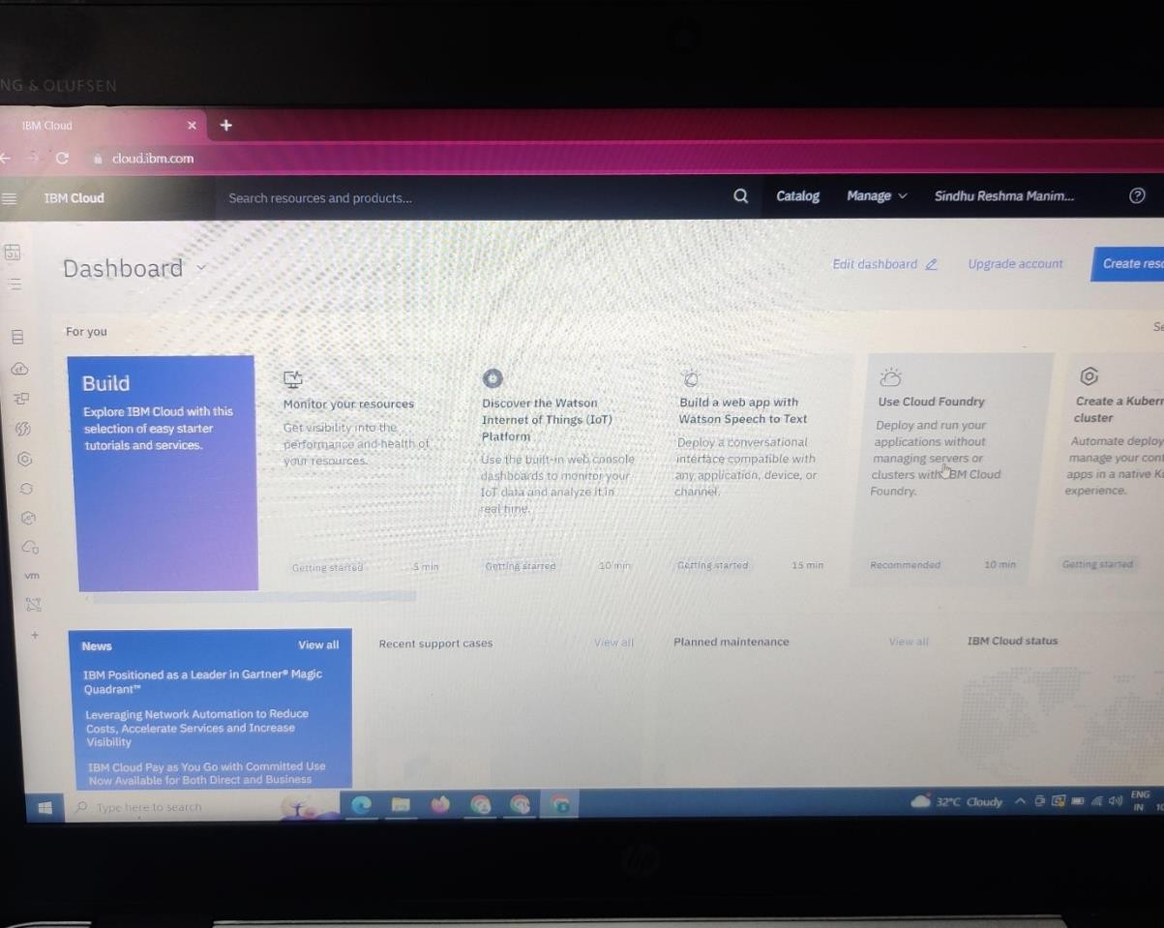

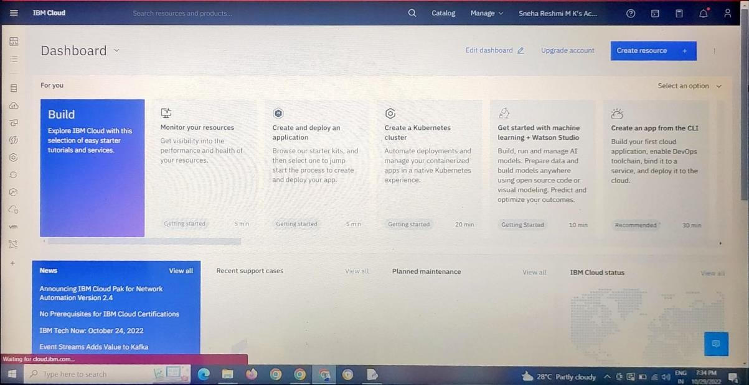

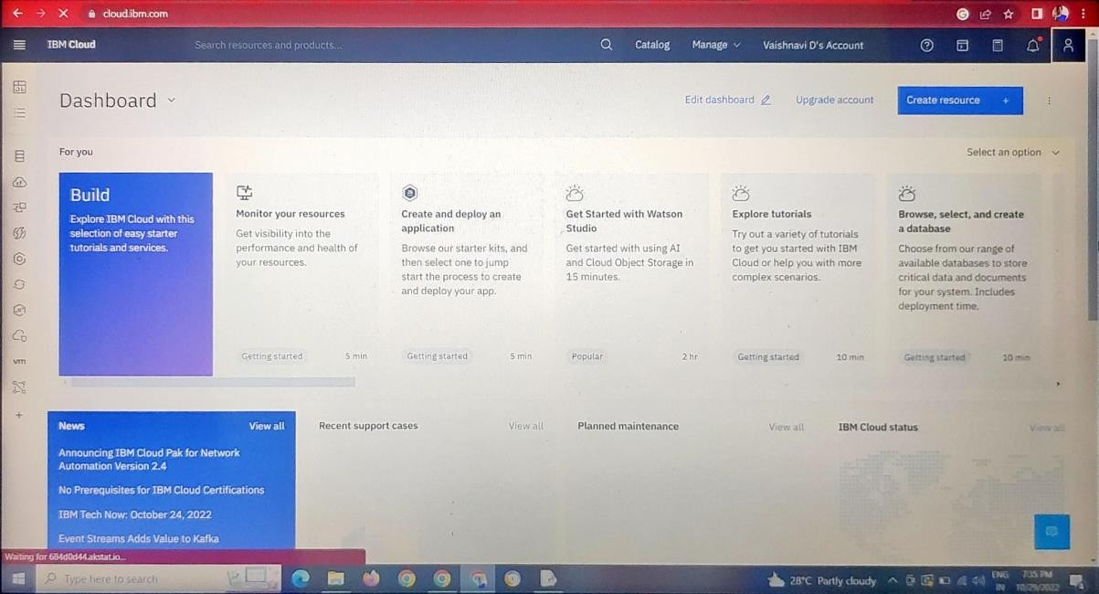

I

